
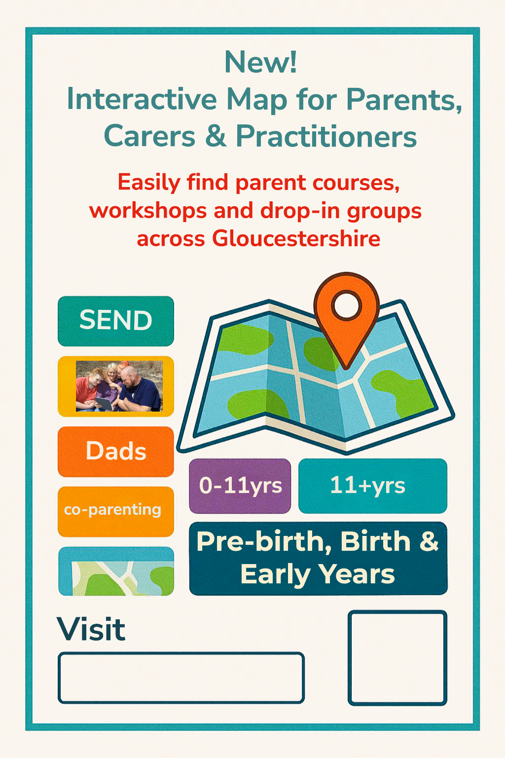
https://www.google.com/maps/d/viewer?mid=1UihniP26UpGrNQ0ArpobWGO81PRkIjY&usp=sharing

