What I have already learned:
EYFS Understanding the World - ELG: The Natural World
Children at the expected level of development will:
- Explore the natural world around them, making observations and drawing
pictures of animals and plants;
- Know some similarities and differences between the natural world around
them and contrasting environments, drawing on their experiences and what
has been read in class;
- Understand some important processes and changes in the natural world
around them, including the seasons and changing states of matter.
What I will learn:
• I can describe how seeds and bulbs grow into plants.
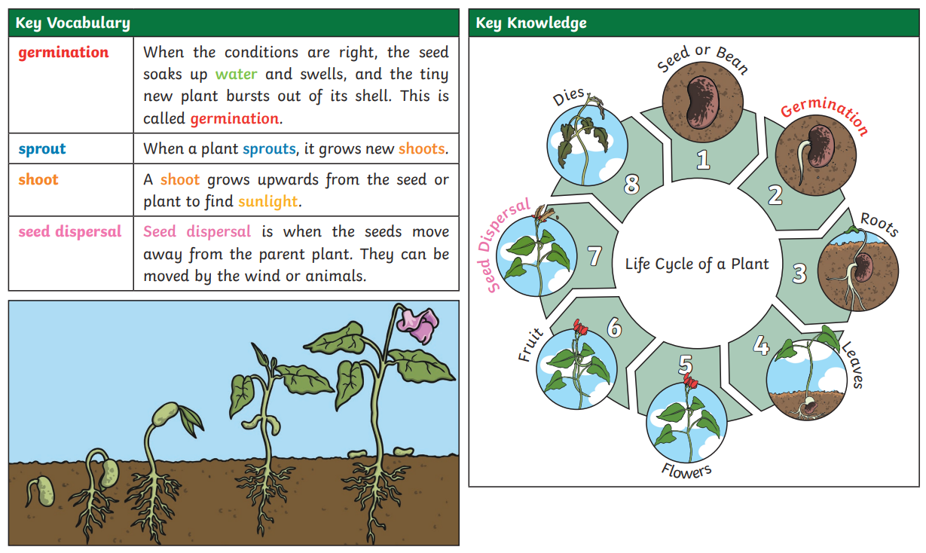
• I can describe what plants need in order to grow and stay healthy (water, light & suitable temperature).
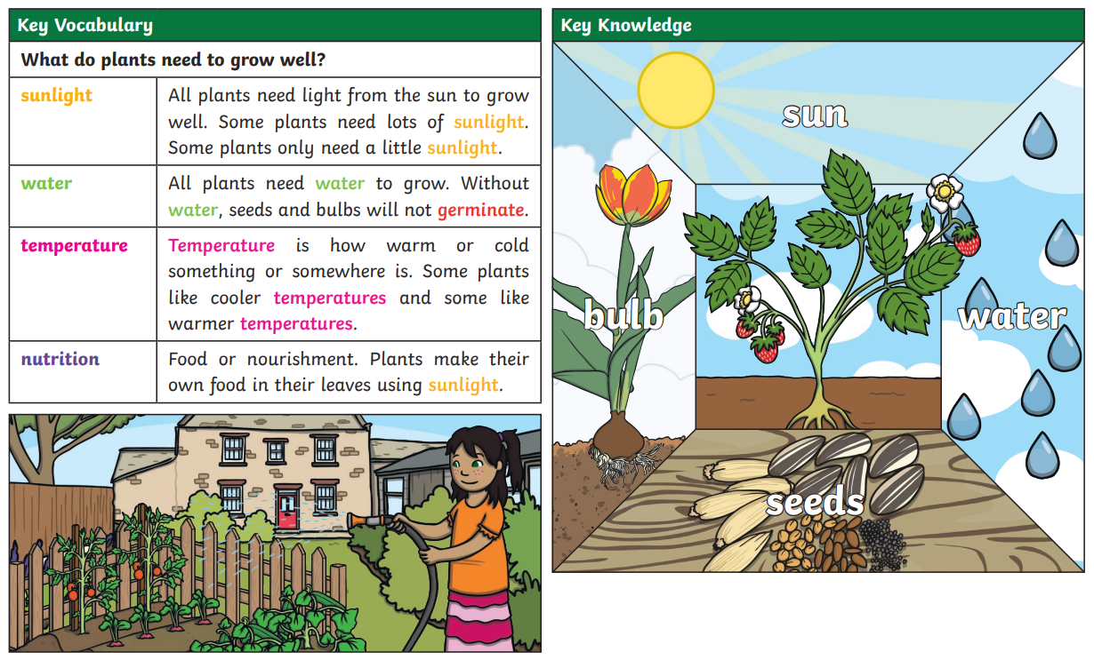
*courtesy of Twinkl
Vocabulary:
As above

