What I have already learned:
EYFS Understanding the World - ELG: The Natural World
Children at the expected level of development will:
- Explore the natural world around them, making observations and drawing
pictures of animals and plants;
- Know some similarities and differences between the natural world around
them and contrasting environments, drawing on their experiences and what
has been read in class;
- Understand some important processes and changes in the natural world
around them, including the seasons and changing states of matter.
What I will learn:
• I can name the parts of the human body that I can see.
•I can link the correct part of the human body to each sense.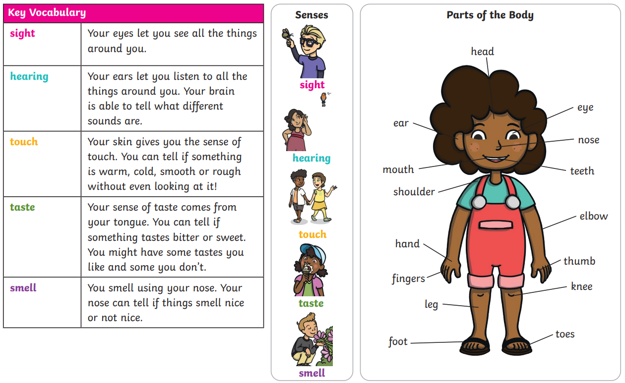
*courtesy of Twinkl
Vocabulary:  sight  hearing  touch | taste  smell  names of body parts

