What I have already learned:
EYFS Understanding the World - ELG: The Natural World
Children at the expected level of development will:
- Explore the natural world around them, making observations and drawing
pictures of animals and plants;
- Know some similarities and differences between the natural world around
them and contrasting environments, drawing on their experiences and what
has been read in class;
- Understand some important processes and changes in the natural world
around them, including the seasons and changing states of matter.
What I will learn:
•I can name a variety of animals including fish, amphibians, reptiles, birds and mammals.
•I can classify and name animals by what they eat (carnivore, herbivore and omnivore).
•I can sort animals into categories (including fish, amphibians, reptiles, birds and mammals). 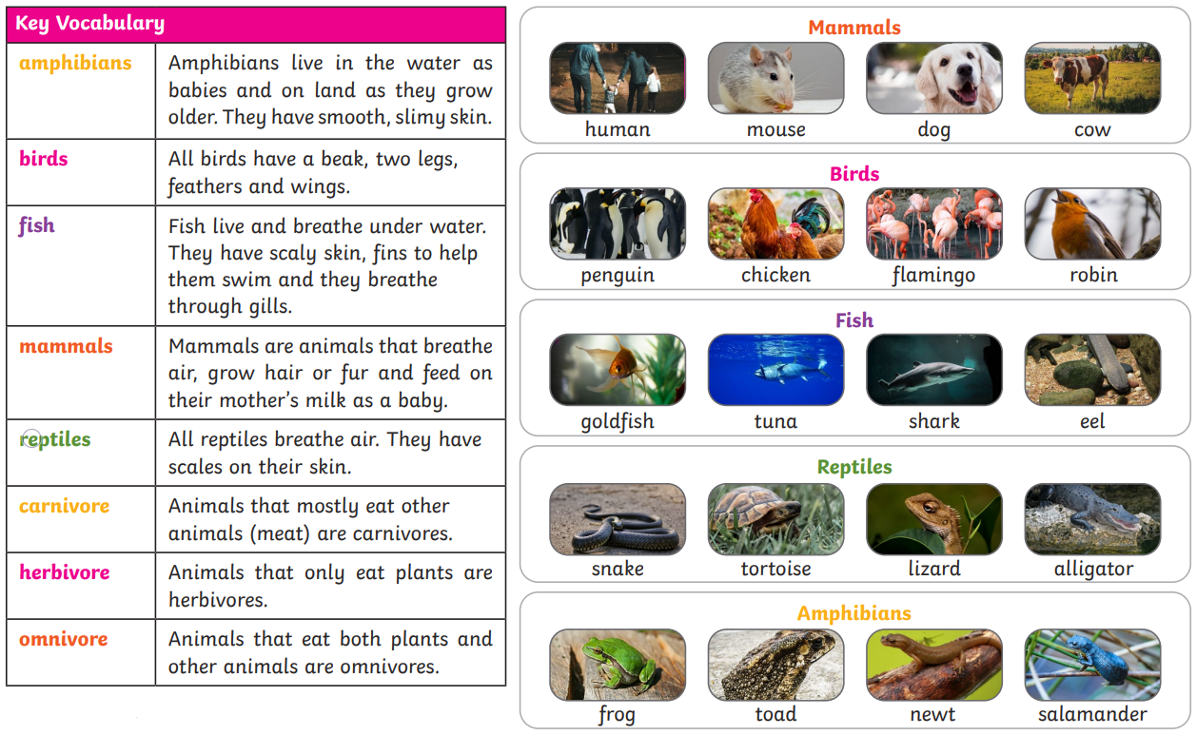
*courtesy of Twinkl
Vocabulary:  amphibian  bird  fish  mammal | reptile  carnivore  herbivore  omnivore

