What I have already learned:
EYFS Understanding the World - ELG: The Natural World
Children at the expected level of development will:
- Explore the natural world around them, making observations and drawing
pictures of animals and plants;
- Know some similarities and differences between the natural world around
them and contrasting environments, drawing on their experiences and what
has been read in class;
- Understand some important processes and changes in the natural world
around them, including the seasons and changing states of matter.
What I will learn:
• I can explain the basic stages in a life cycle for animals, including humans.
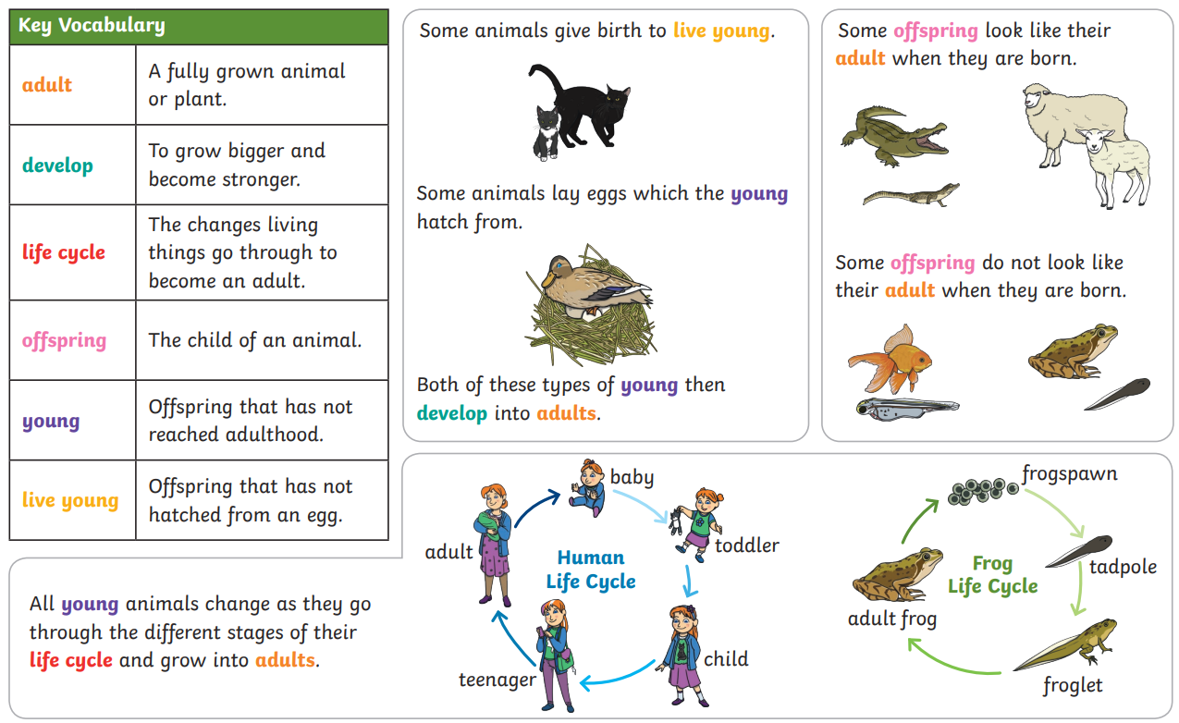
*courtesy of Twinkl
Vocabulary:  adult  develop  life cycle | offspring  young  live young

