How to Wash Your Hands
Do you know how to wash your hands? Look carefully at the pictures and then cut and stick them in the correct order.

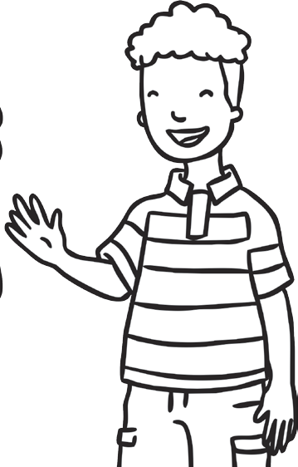

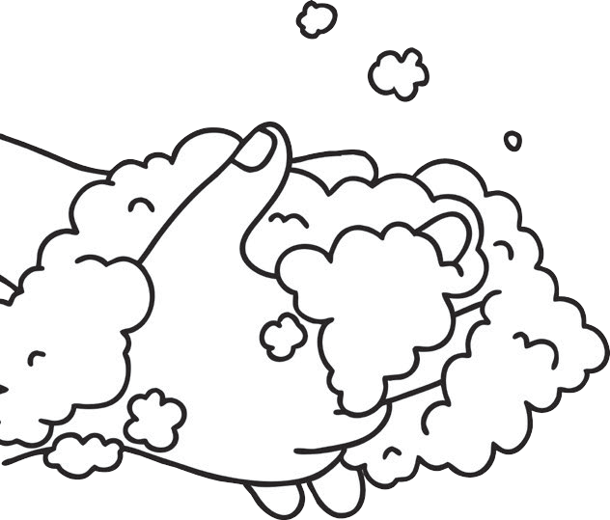
Can you tell a grown up all about how and why we wash
our hands?
visit twinkl.com
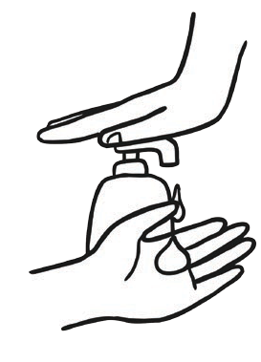
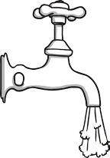
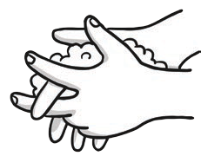

twinkl.com  Wash away the soap bubbles. | twinkl.com  Put soap on your hands. | twinkl.com  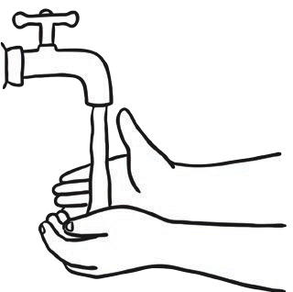  Rinse your hands with water. | twinkl.com  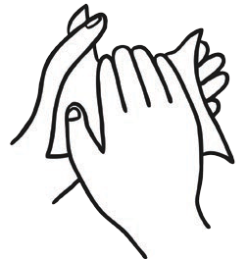  Dry your hands. | twinkl.com  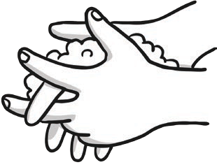  Rub your hands together.

