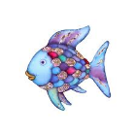 The Rainbow Fish Story Comprehension 

What colour were Rainbow Fish's scales?

Where did Rainbow Fish live?

Why didn’t the other fish want to play with the Rainbow Fish?

Who did Rainbow Fish go and see for help?

What did the octopus tell Rainbow Fish to do?